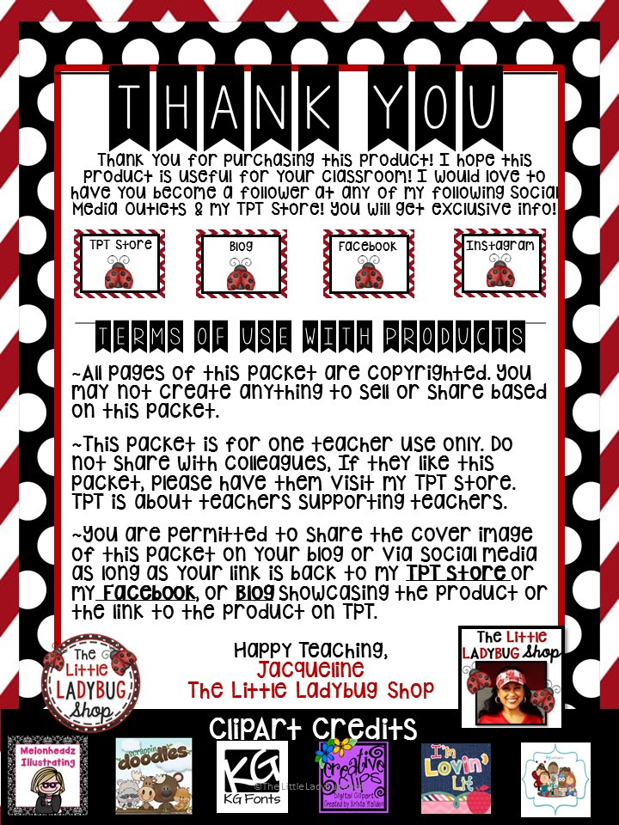

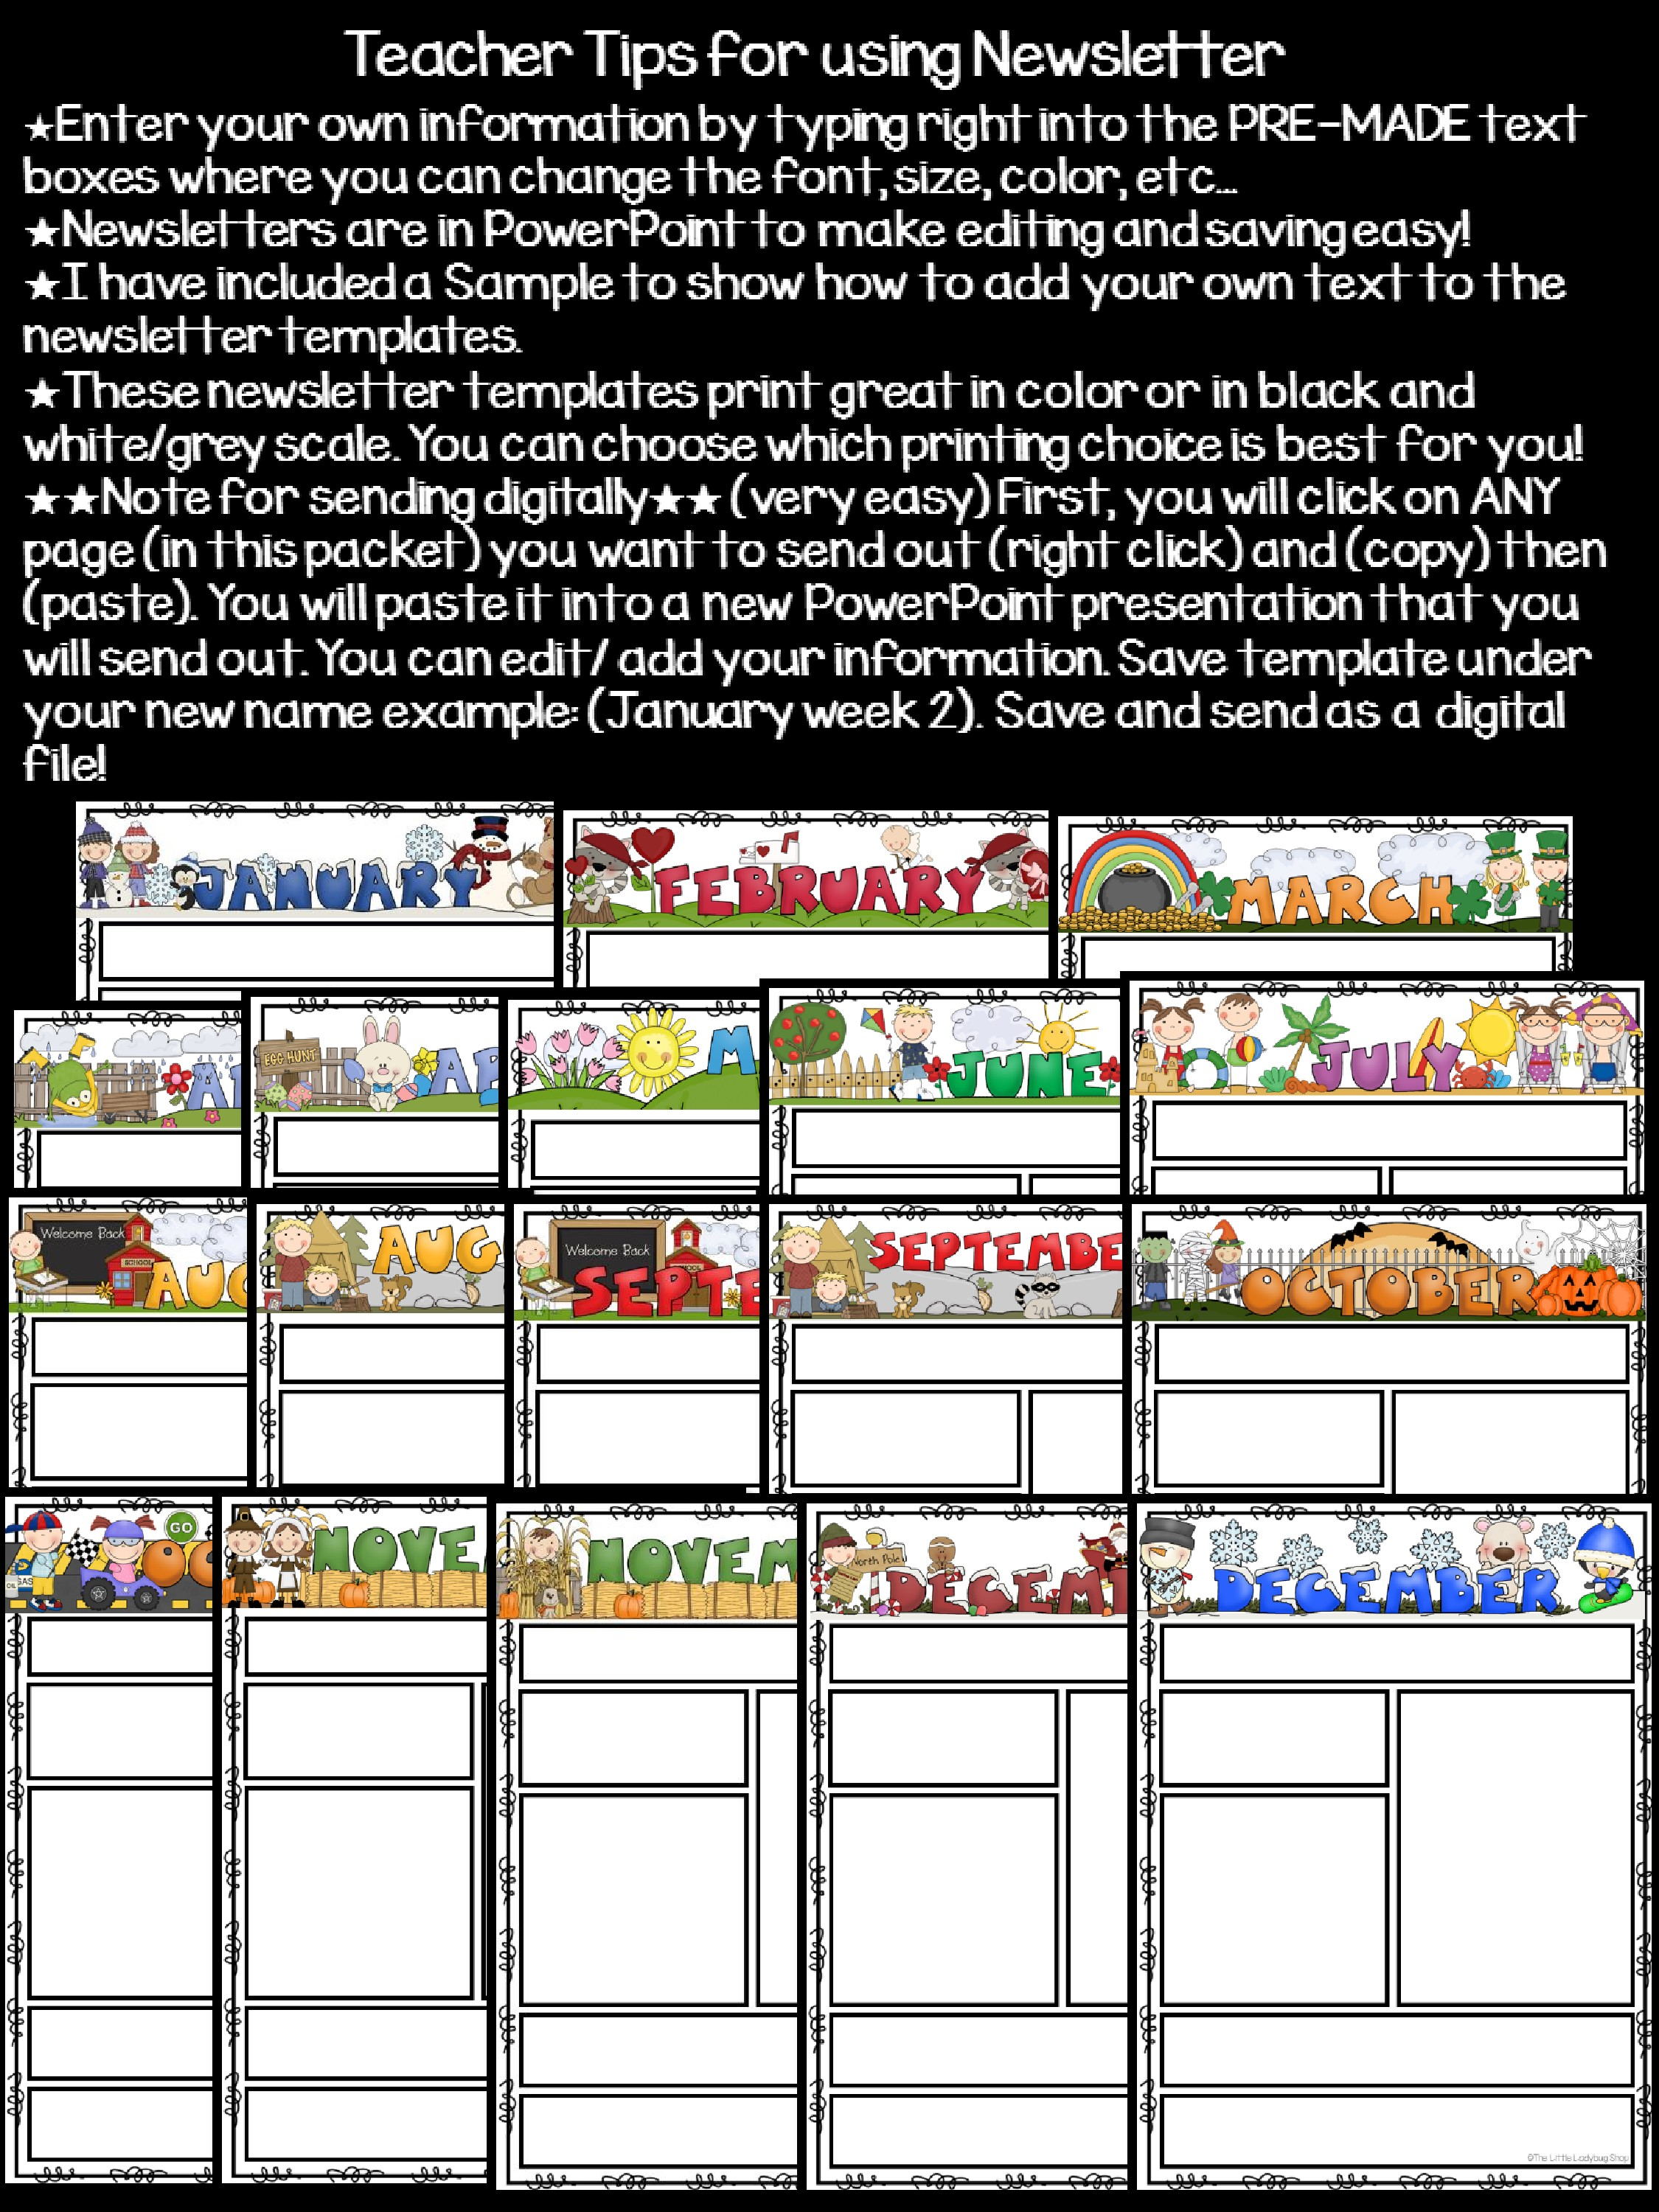

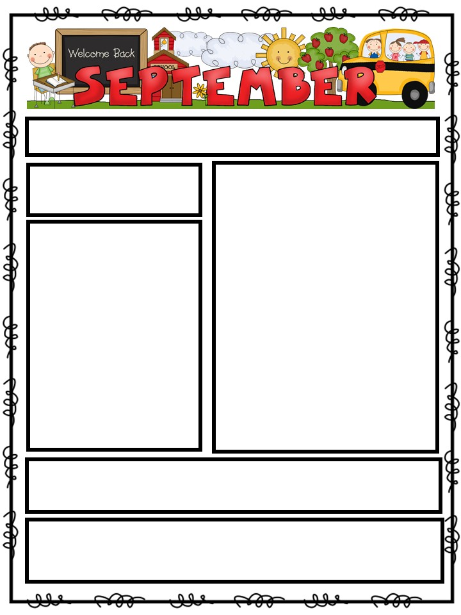

**Teacher: Mrs. Apple’s Classroom**

What We Will Be Working On…

**Language:**

We will be reviewing

Types of Sentences. We will

create Friendly Letters

**Reading:**

We will be introduced

to Fiction Genre. Students will

begin 1

st

Book Club Meeting with

Group.

**Math:**

We will begin 2 digit

multiplication. We will review

patterns.

**Science**

:

We will review the plant

life cycle.

**Conference Hours**

: 1:30

-

2:15

**Student lunch Time:**

12:00

-

12:30

**Recess**

: 12:30

-

1:00

**Homework**

Spelling Words Their Way

Read Daily 20

Minutes

Math Daily Homework Packet

**Important Dates:**

Parent Teacher

Conferences: 9/12

First Math Quiz: 9/13

Science Unit 1 Test:

13

/

9

**Week of:**

September 1

-

2015

,

5

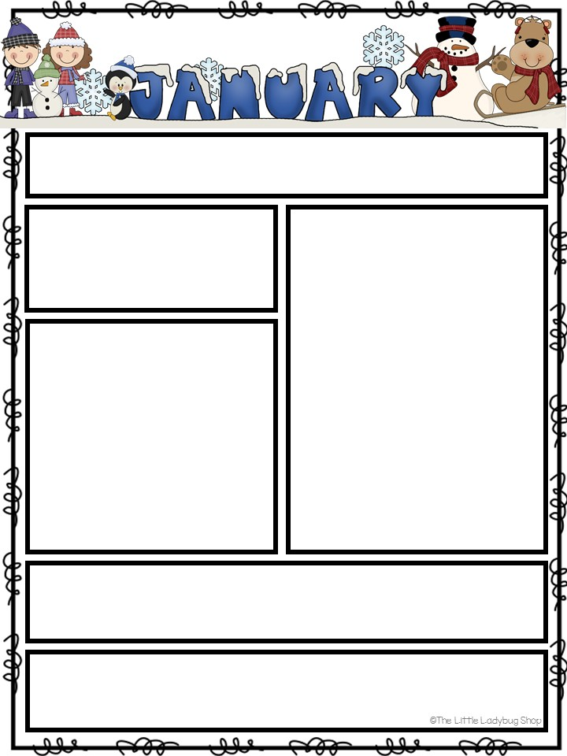

Editable

Editable

Editable

Editable

Editable

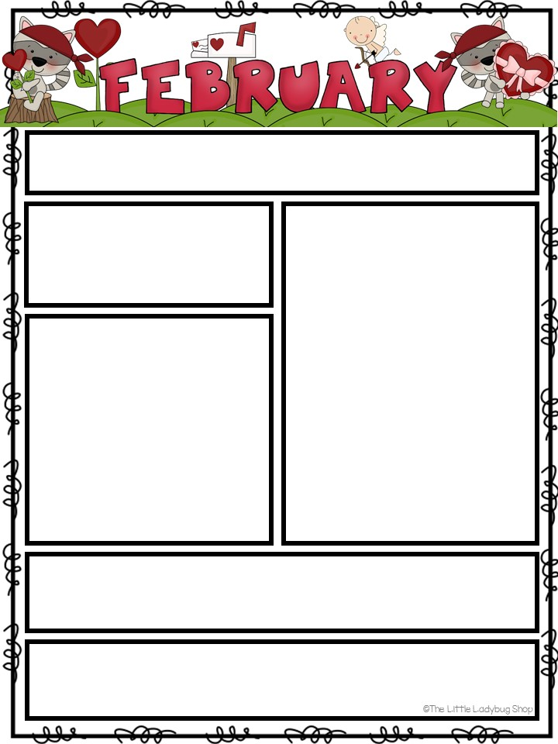

Editable

Editable

Editable

Editable

Editable

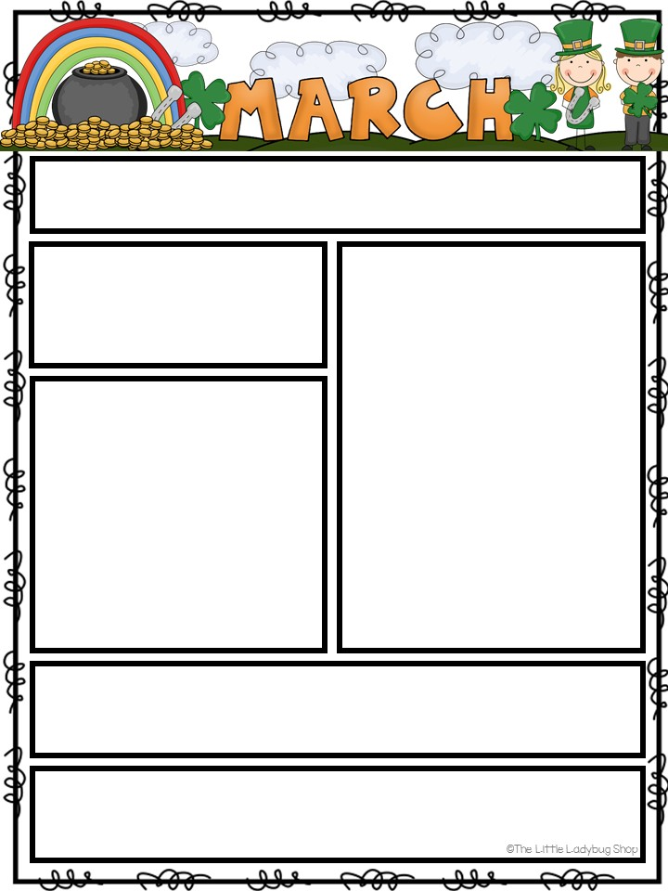

Editable

Editable

Editable

Editable

Editable

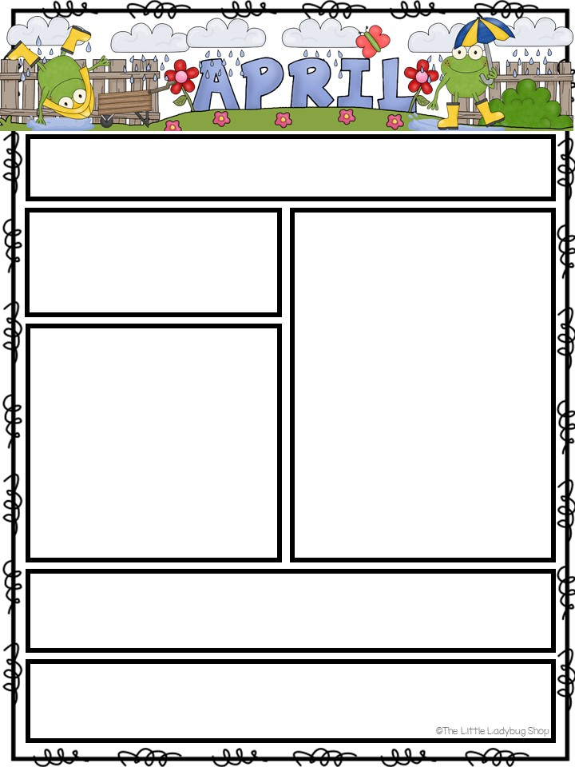

Editable

Editable

Editable

Editable

Editable

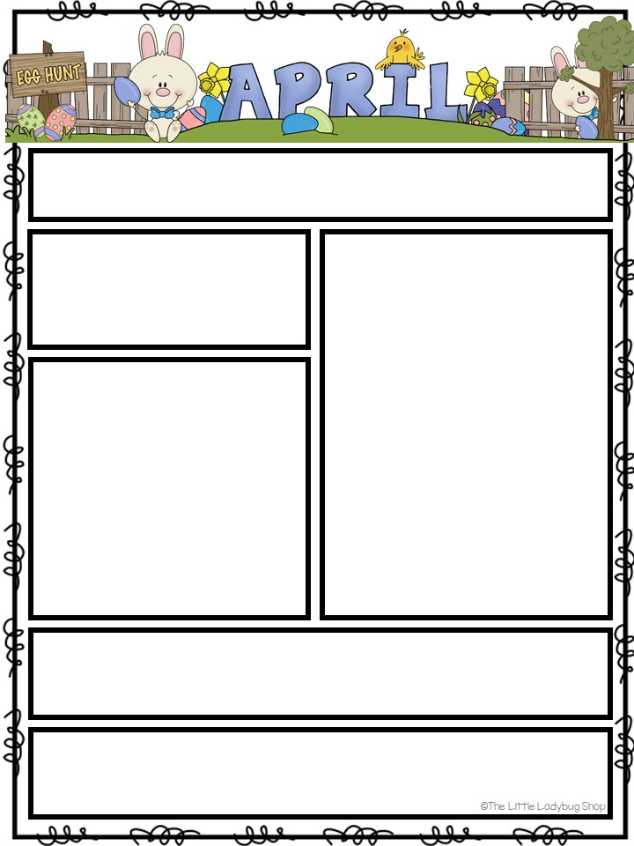

Editable

Editable

Editable

Editable

Editable

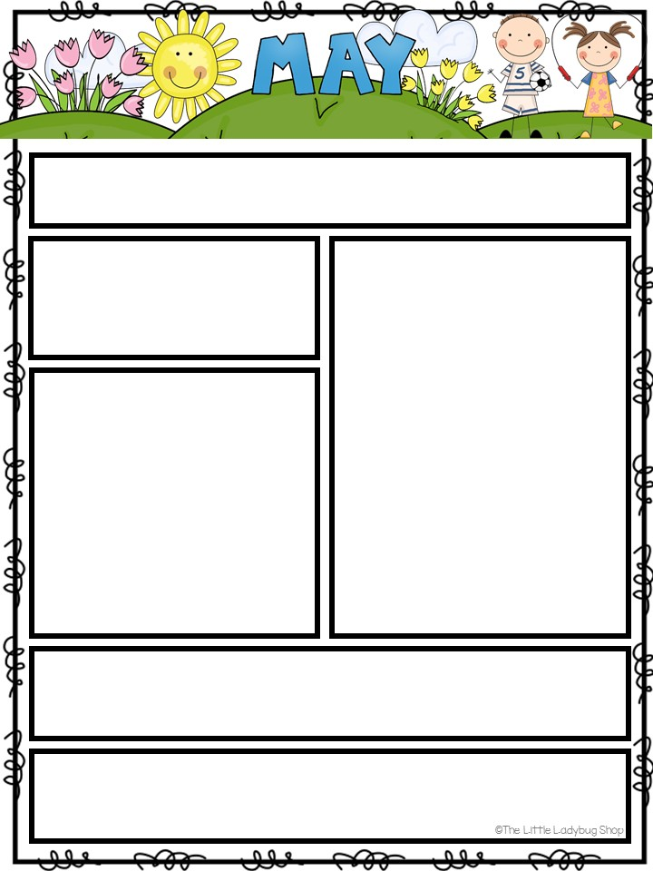

Editable

Editable

Editable

Editable

Editable

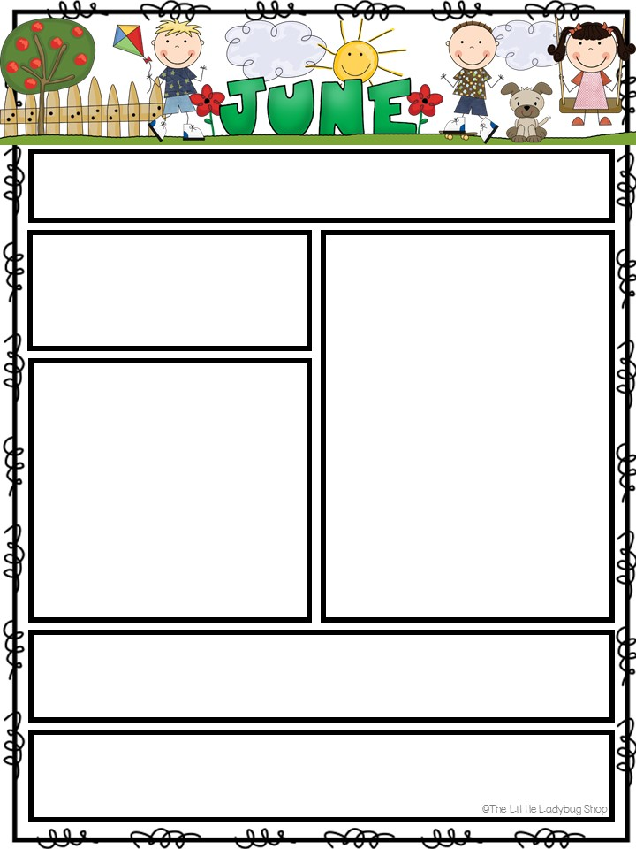

Editable

Editable

Editable

Editable

Editable

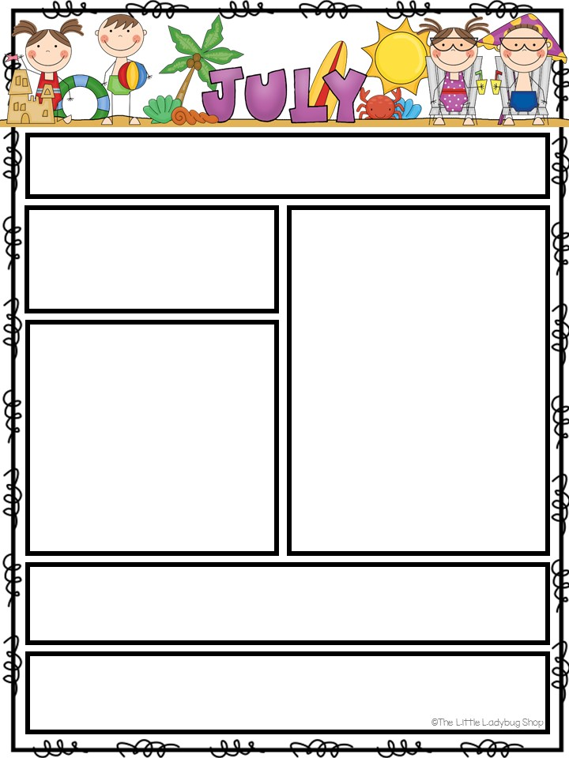

Editable

Editable

Editable

Editable

Editable

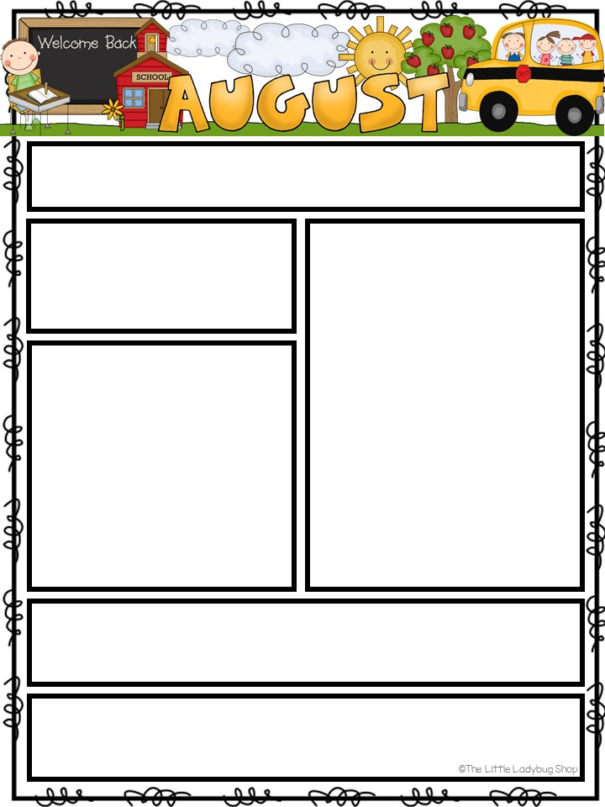

**Upcoming Dates/Events**

August 23:

Chik

-

fil

-

a Night

August 2: School Pictures

August 27

th

:

Rome Braves

Night

**Themes for the Month:**

3

8

/

-

8

/5: Into a Routine

8

/

8

-

/12: Back to School

8

8

/

15

-

8

/19: Me, My Body, My

Family and Friends

8

/

22

-

8

/26: Circus

Off to a Great Start!

We are getting settled

and into a great

routine!

**Our Classroom Rules**

Quiet Lips

Gentle Hands

Walking Feet

**Birthdays for the month of August**

Ms. Bree

-

August 20

Please consider joining our

**CPS Facebook Page**

**cartersvilleprimaryschool@WeAreCPS**



Mrs. Houston and Ms. Bree

**Guire and Ms. Bree Classroom Newsletter**

**Off to a Great Start!** We are getting settled and into a great routine!

# Our Classroom Rules



Quiet Lips

Gentle Hands

Walking Feet



**Upcoming Dates/Events**

August 23: CiCi’s Spirit

Night

August 24: School Pictures

August 27th: Rome Braves Night

Themes for the Month:

8/3-8/5: Into a Routine

8/8-8/12: Back to School

8/15-8/19: Me, My Body, My Family and Friends

8/22-8/26: Circus

# August Birthdays

Ms. Bree - August 20

Please join our CPS Facebook Page cartersvilleprimaryschool@WeAre CPS

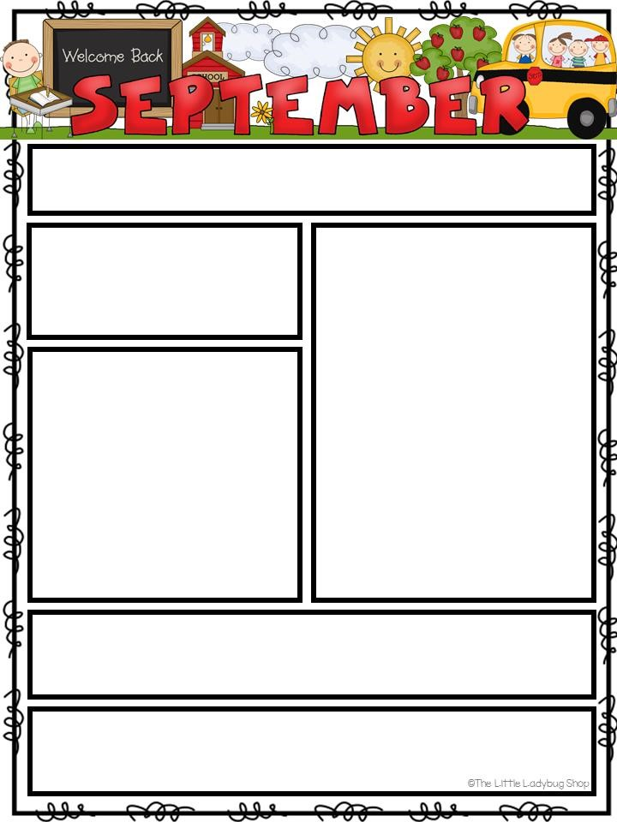

**Mrs.**

**Maguire**

**and Ms.**

**Kris**

We are CPS Proud and Strong! We are CPS!

Character Word of the Month:

Respect



**Please Remember**

**Initial your child’s**

**progress sheet**

**daily!**

**Upcoming Dates/Events**

9

/4: Labor Day

–

No School

9

/7: CFA Night

9

/19: Fall Picture Day

9

/22: CHS Homecoming

Parade

9

/26:

CiCi’s

Night

**Themes for the Month:**

/

4

9

-

9

/8:

Community Helpers

9

/

11

-

9

/15: Cowboy

9

/

18

-

22:

Farm & Farm Life

9

/

25

-

9

/29: Apples



**Our Classroom**

**Rules**

Quiet

Lips

Gentle

Hands

Walking Feet

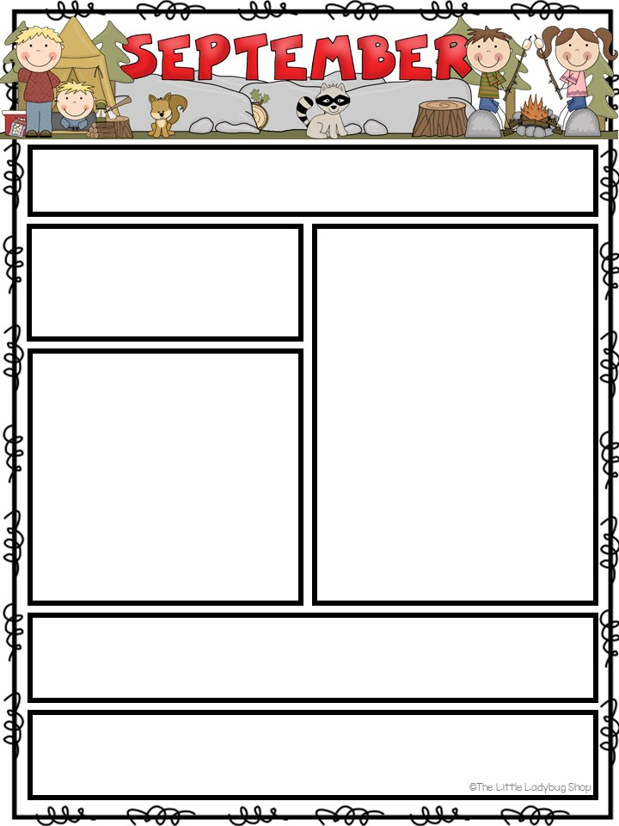

Editable

Editable

Editable

Editable

Editable

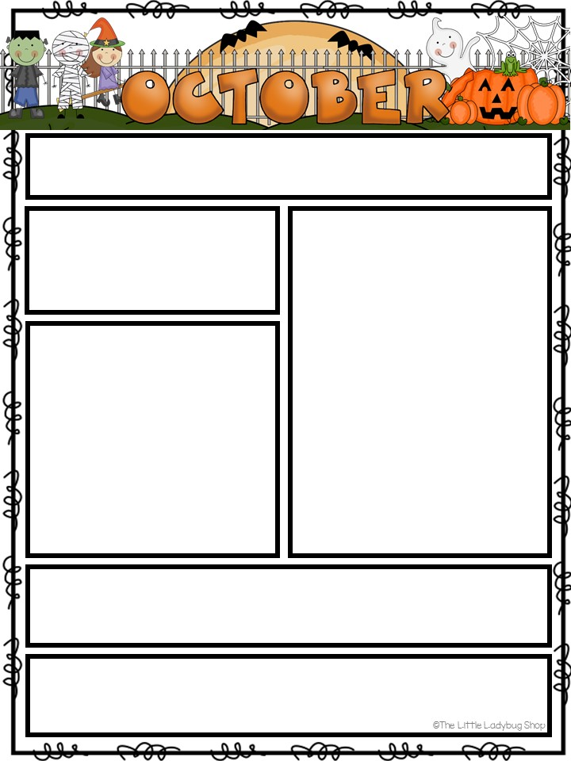

Ms. Maguire and Ms. Kris Classroom Newsletter

**Important Dates for the**

**Month:**

**Oct. 1**

**-**

**5:**

Book Fair Week

**Oct. 3:**

Flu Shots

**Oct. 4:**

Family Book Fair

Night

**Oct. 5:**

High Five Friday

**Oct. 8-9:**

Fall Break

**Oct. 11:**

Chic Fil A Night

**Oct. 16:**

Progress Reports

**Oct. 19**

:

High Five Friday

**Oct. 20:** Fall Festival 10-2:00

**Oct. 22-26:** Red Ribbon and National School Bus Safety Week

**Oct. 25:** Cheeseburger Bobby Night

October Character

Word of the Month:

Citizenship

What We Will be

Learning:

**Fall, Farm,**

**Pumpkins and**

**Halloween**

**Red Ribbon Week**

**October 22**

**-**

**26**

**Book Character Parade Day**

**9:00 (More information to come later)**

More information to come!

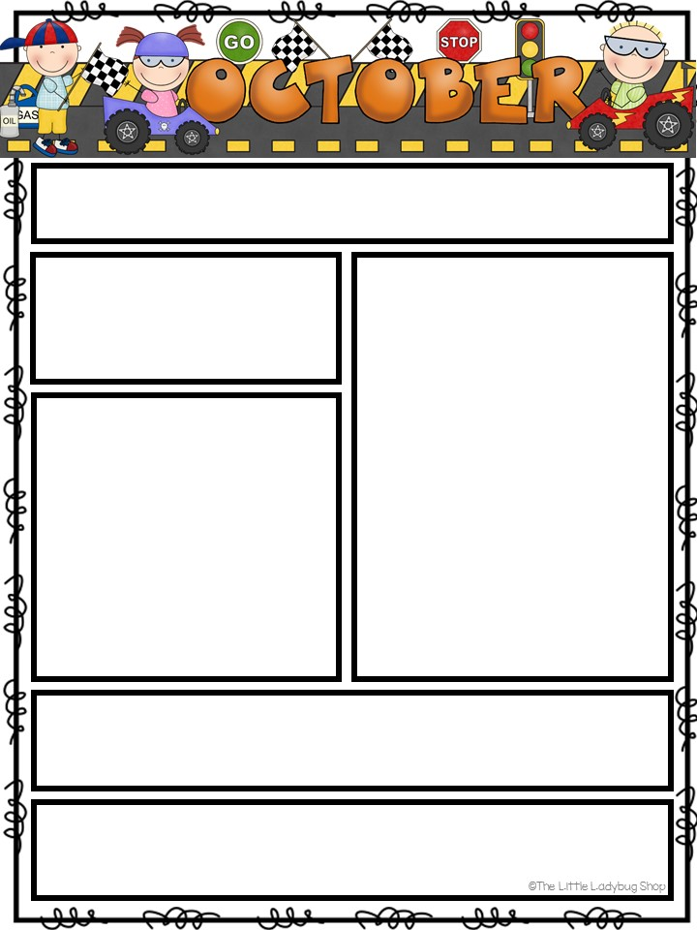

Editable

Editable

Editable

Editable

Editable

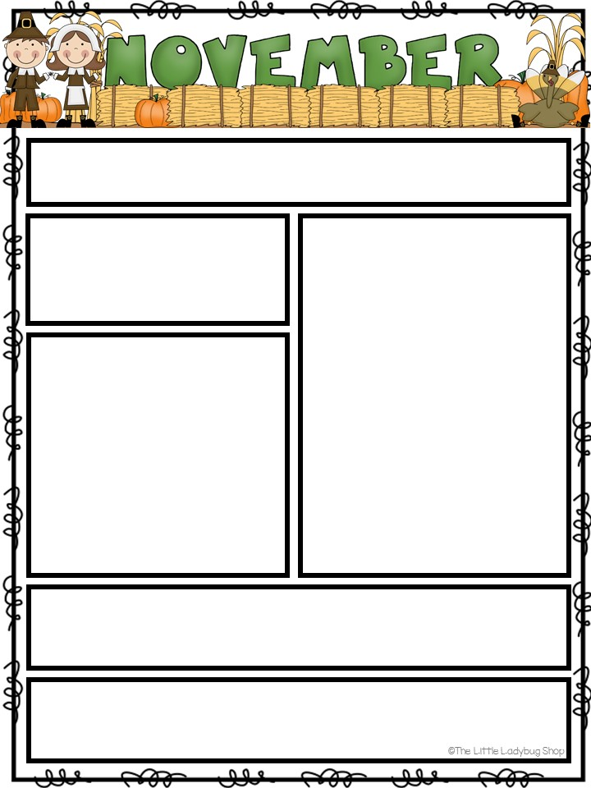

**Ms. Maguire and Ms. Kris Classroom Newsletter**

**Upcoming Events and**

**Dates:**

**Tues. 10/31:**

Happy

Halloween

**Fri. 11/3:**

Back Pack Buddy

Day

**Thurs. 11/9:**

Veteran’s Day

Program and

Chic Fil A Night

**Mon. 11/20**

**–**

**11**

**/24**

Thanksgiving Break

**Mon. 11/27:**

School

Resumes

**Tues. 11/28:**

CiCi’s

Night

November

Character Word of

the Month:

**Cooperation**

What We Will be

Studying this

month:

**Pilgrims/Indians,**

**Turkeys, and**

**Table**

**Manners/Setting**

Hope you all have a very happy , safe and

thankful Thanksgiving!

We are CPS Proud and Strong!

We are CPS!

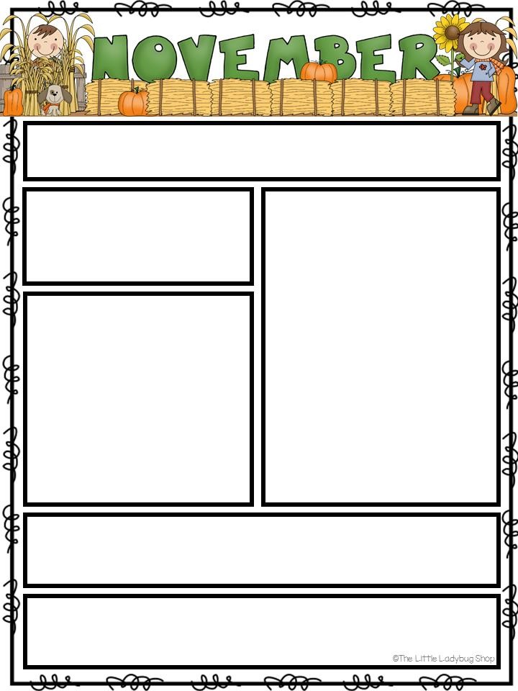

Editable

Editable

Editable

Editable

Editable

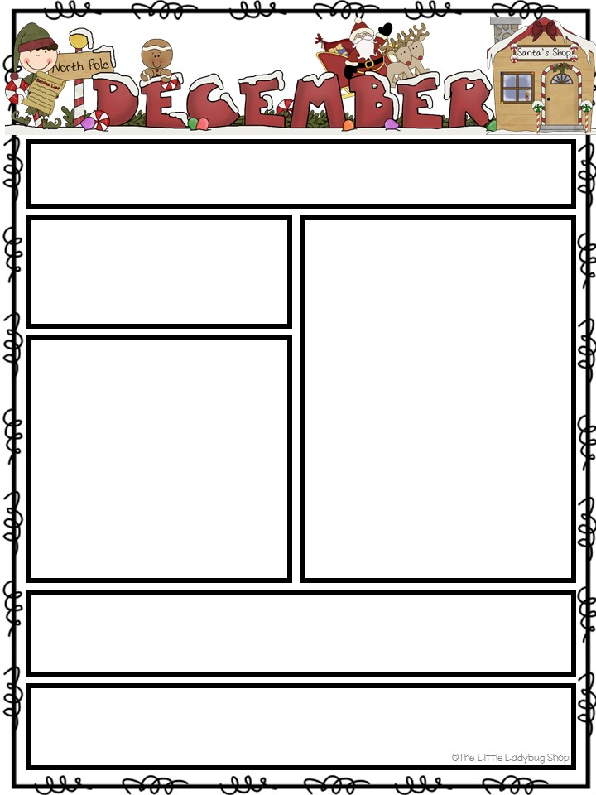

Guire

and Ms. Bree’s Classroom

**Upcoming Events/Dates:**

**Thurs, Dec 1:**

Community

Holiday Parade Downtown

**Tues, Dec 6:**

Santa Night at

CPS

**Thurs, Dec 8:**

“Extreme”

Purple and Gold Day

**Fri, Dec 9:**

The Grinch Who

Stole Christmas Day (Wear PJ’s)

**Dec 12**

**-**

**16**

:

Holiday Dress Up

**Thurs, Dec 15:**

Holiday Party

(

More to come

)

**Fri, Dec 16:**

Last Day of

School

**Sat, Dec 17**

**–**

**Mon, Jan 2:**

Christmas Holidays/No School

**Tues, Jan 3:**

First Day Back to

School

**Upcoming Themes:**

Gingerbread,

Santa/Elves, Reindeer,

and Christmas Trees

Holiday Dress Up Week:

**Dec. 12**

**–**

**16**

Mon.

-

**S**

**anta**

**H**

**ats**

Tues.

–

**R**

**eindeer**

**Antlers/Noses**

Wed.

–

**Holiday Socks**

Thurs.

–

**Holiday Attire**

Fri.

–

**Red,Green,White**

December Character Word of the Month:

**Caring**

Please help cheer on our CHS Purple Hurricanes all the

way to The Dome! Let’s Go Canes! We are Proud and

Strong!

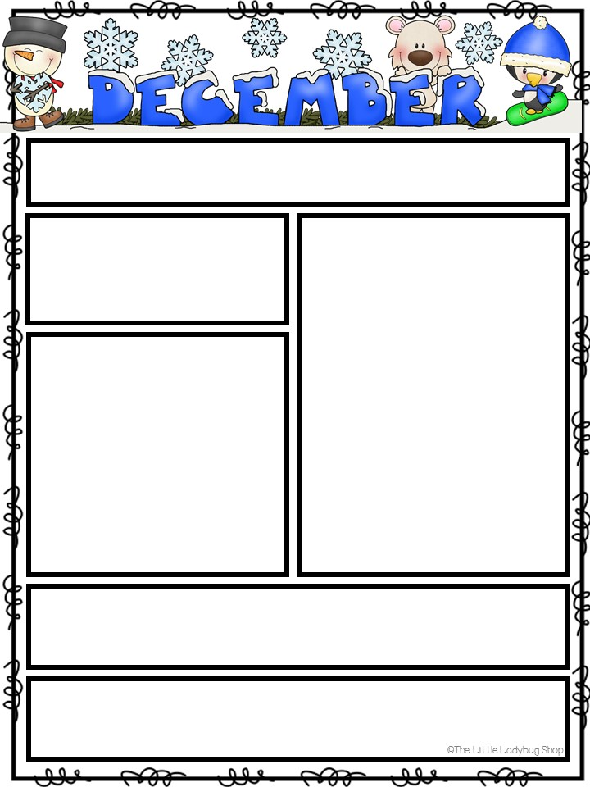

Editable

Editable

Editable

Editable

Editable