Percussion Class

*(Mastery Band I, II, III, or IV)*

8:30 am – 10:00am

Band Room

Mr. Mike Long Mr. Samuel Brooke

[Mlong@Cartersvilleschools.org](mailto:Mlong@Cartersvilleschools.org) [Sbrookepercussion@gmail.com](mailto:Sbrookepercussion@gmail.com)

**770-387-4782**

CHS Band Website

<https://www.cartersvilleschools.org/domain/1965>

The Cartersville Percussion Class is a performing ensemble within the Cartersville High School Band Program. This ensemble performs music from grade II-V as an independent ensemble and alongside the Concert/Symphonic Bands.

**PLEASE RETURN THE SIGNATURE PAGE BY 8/14/2023**

## Members of the Percussion Class

1. And their parents will download the BAND App and scan the QR Code on the back to join our band.
2. Will attend after school rehearsals on assigned days as deemed necessary by the directors.
3. Will perform in all concert performances per the calendar.
4. Will practice a minimum of 150 minutes per week.
5. Will keep the instrument in excellent condition and always have supplies & music within reach.
6. **Will read and adhere to all polices located in Band Handbook / Student Handbook on our website.**
7. Will transfer all Cartersville Band Concert Dates/Events to home calendar ASAP located on the webpage.

### Percussion Class Grading: All assignment dates are listed on the back of this syllabus

1. **Formative Grades (40%)** **– “Check-ins”**

* These are quick formal formative assessments in class where each student will play a short passage of music or scale that the class has worked on as a group for a minimum of 2 weeks.

1. **Summative Grades (60%) – “Pass Offs” and Concert attendance**

* These are formal summative assessments where students sign up for a time to perform their concert music in front of a director. These serve as a major check point in a student’s development as a musician and also confirms that they are prepared for the upcoming concert.
* Students who fail to attend their band concert will receive a zero for that summative grade.

1. **Final Exam** – At the end of a semester course, the Final Course Average is calculated with 90% (semester grade) and the Final Exam, 10%.
2. **Extra Credit-**Concert Attendance

Attendance at 5 other concerts such as ASO, feeder schools, youth symphonies etc…

***\*\*Must present a program and/or ticket stub for credit***

**Important Dates:** **The Band App (for students)**

* + - * 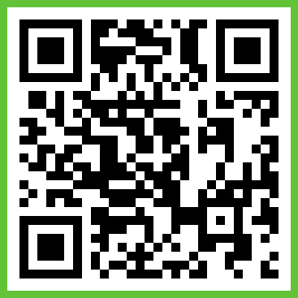**September 19: Fall Band Concert**
      * October 4: District Jazz Band Auditions
      * November 13-14: District Jazz
      * **December 4: Winter Band Concert**
      * December 9: District Honor Band/All State 1st Round Auditions
      * January 6: All State Final Auditions
      * January 25-27: All State Jazz
      * February 8-10: District Honor Band
      * **February 15: Pre-LGPE Concert**
      * February 29 – March 1st: All State Band **The Band App (for parents)**
      * 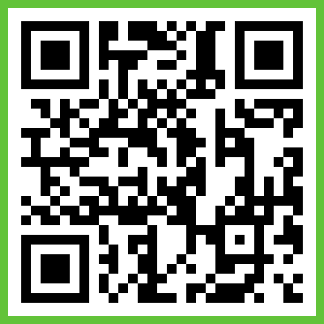**March 5: Jazz Concert**
      * **March 11 - 12: LGPE Window**
      * **April 23: Spring Concert #1**
      * **April 25: Spring Concert #2**
      * April 20 – Solo and Ensemble
      * **May ?? – Band Banquet**

**Assessment Dates:**

**Check – ins (Formative Assessments): 8/23rd, 10/4th, 10/25th, and 11/29th**

**Pass – Offs (Summative Assessments): 9/6th and 11/15th**

As a member of the Cartersville High School Band Program, I will adhere to the rules, polices and regulations provided in this syllabus and follow the “Canes Code” to the best of my ability. I understand that any deviation from this will result in a lowering of my grade or other penalties at the discretion of the Director of Bands.

As a parent/guardian, I will do my best to support my child in all band related activities in which they are actively involved and encourage their musical growth.

_________________________________________ ____________________

Student’s Signature Date

_________________________________________

Student’s Printed Name

________________________________________ ___________________

Parents(s)/Guardian(s) Signature Date